
Getting ready for your Annual Health Check

Annual Health Checks are:
To help you stay well and healthy
About having an Annual Health Check – click link for Easy Read Guide
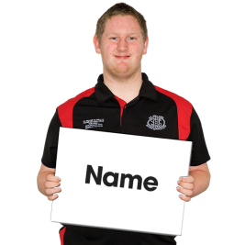 | Name:
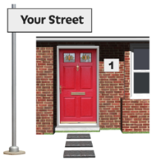 | Address:
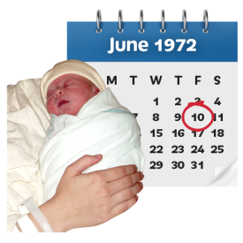 | Date of birth:
 | Phone:
 | Email:
 | Please remind me of appointments by:  - Text  - Phone  - Email  - Letter/post
Summary care records

If you would like extra information on your summary care record about your health and what support, you need let your Doctor know.

Please answer Yes or No to say if you need more information.

For Easy Read resources about Summary Care Records click here
Yes/No | I would like extra information on my Summary Care Record.

Consent to sharing information

Consent is being asked if you agree to something.
This means saying yes or no to the questions below.

Please answer Yes or No to say if you agree.

For easy read resources about consent click here
Yes/No |  | - Consent for electronic record sharing?
Yes/No |  | - Consent to share data with another Professional? (Someone who works to help you)
Yes/No |  | - I am not able to consent to sharing my information.
Yes/No |  | - It has been agreed that it is in my Best Interest to share information.
Reasonable Adjustments

A reasonable adjustment is a change your Doctor needs to make so going to the surgery is easier for you. Please answer Yes or No for ways we can help you.
 | I need Easy Read documents. | Yes/No
 | I need information in Braille. | Yes/No
 | I need information in Large print. | Yes/No
 | I need an interpreter. | Yes/No
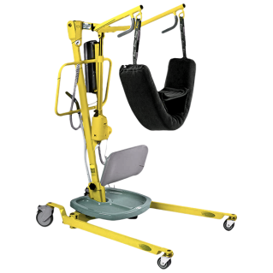 | I use a wheelchair and I will need a hoist if I need a physical examination. | Yes/No
 | I may need a home visit. | Yes/No
  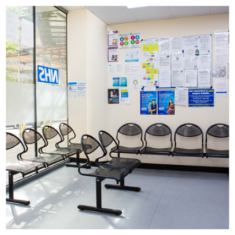 | I would like to come at quiet times, because I find it difficult waiting for my appointment. | Yes/No
 | I may need to wait outside until you are ready to see me. | Yes/No
 | Bright lights or loud noises may affect me. I may need to sit in a quiet room. | Yes/No
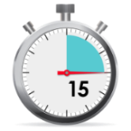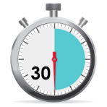 | I need longer Appointments |  | Yes/No
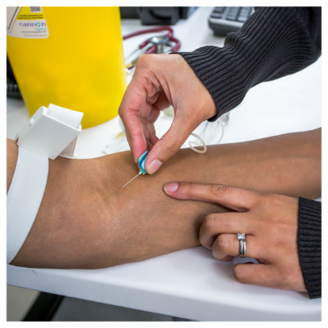 | I need support with medical procedures.  Like having an injection, blood test or blood pressure test. |  | Yes/No
 | Please say how you have tolerated these tests in the past (what has helped make them easier for you).
 | My carer will support you to understand my needs. |  | Yes/No
 | I get very nervous at appointments and need my carer to support me. |  | Yes/No
 | Please tell my carer about any appointments. |  | Yes/No
 | These are the other things that will help me…
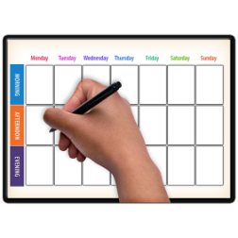 | Your measurements  This is really important and helpful information
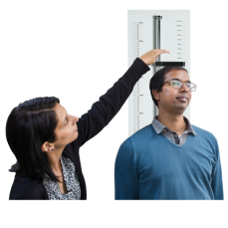 | Height
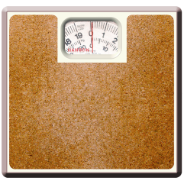 | Weight | (Are you putting on weight or losing weight?)
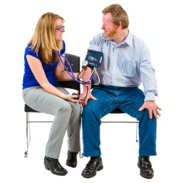 | Blood Pressure
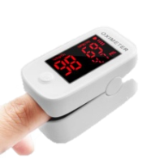 | Other
Please choose Yes or No to tell the doctor about any problems and what is important for you

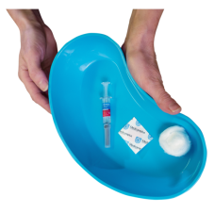  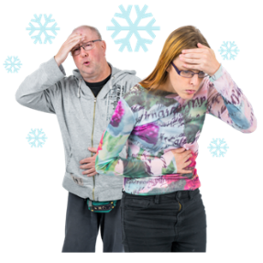 | Flu | Answer | Your notes...  
 | Have you had your nasal spray or a flu vaccine injection? | Yes/No
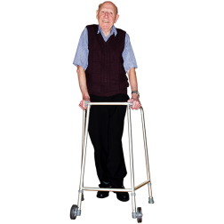   | Mobility  moving | Answer | Your notes...
 | Stiffness or difficulty moving? | Yes/No
 | Pain when moving? | Yes/No
 | Falling or tripping? | Yes/No
 | Changes in posture or mobility? | Yes/No
 | Swelling or redness in limbs or skin | Yes/No
 | Mobility equipment used | Yes/No
 |  | Being Healthy | Answer | Your notes...  
 |  | Diet  Do you eat fruit and vegetables? | Yes/No
 |  | Exercise  Do you exercise? | Yes/No | What exercise do you do?
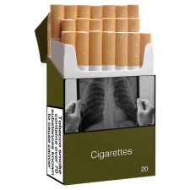 |  | Smoking  Do you smoke/vape? | Yes/No | How much do you smoke/vape in a day?
   |  | Alcohol  Do you drink alcohol? | Yes/No | How much alcohol do you drink in a week?
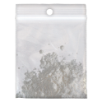 |  | Drugs  Do you use illegal drugs? | Yes/No | If Yes, which ones?
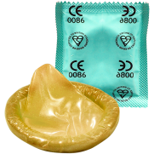 |  | Sexual Health & Contraception | Answer | Your notes...
 |  | Do you have sex? | Yes/No
 |  | Do you use contraception? | Yes/No
Guides to support people with learning disabilities with issues around sex and relationships

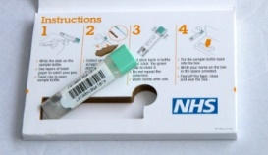 |  | Bowel Cancer check | Answer | Your notes...
 |  | Are you aged  60-74? | Yes/No | Age:
 |  | If yes, have you received your bowel test kit? | Yes/No
Bowel Screening an Easy Guide: Click here

 | Female health checks |  | Answer | Your notes...
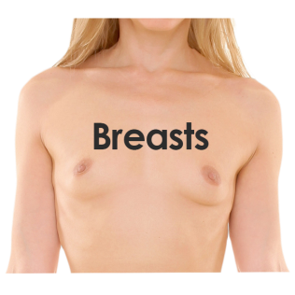 | Do you check your breasts? |  | Yes/No
 | Have you seen or felt changes to your breasts? |  | Yes/No
 | Have you had breast screening? (age 50+) |  | Yes/No
 | Have you had a smear test? |  | Yes/No
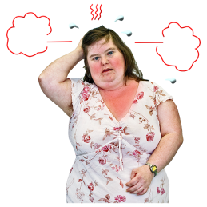  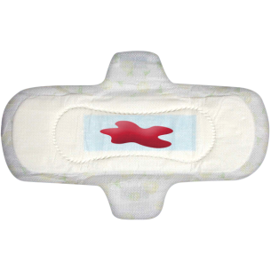 | Change in periods? e.g. heavy bleeding in between periods |  | Yes/No
 | Painful periods |  | Yes/No
 | Vaginal discharge |  | Yes/No
 | Menopause symptoms |  | Yes/No
USEFUL LINKS AND INFORMATION

Puberty and period in girls with developmental delay

An easy guide to cervical screening

An easy guide to breast screening

Supporting people with learning disabilities to take care of their breasts

How to check your breasts

 | Male health checks |  | Answer | Your notes...
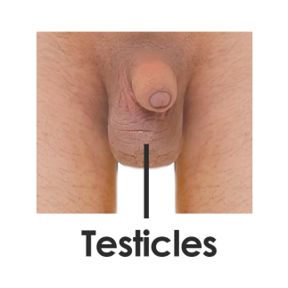 | Do you check your  testicles / balls? |  | Yes/No
 | Have you seen or felt changes to your  testicles / balls? |  | Yes/No
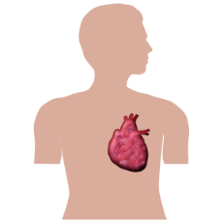 | Have you had your  Abdominal Aortic  Aneurysm or AAA  check? (Age 65 +)? |  | Yes/No
USEFUL LINKS AND INFORMATION

Puberty in boys with developmental delay

How to look after my balls

Abdominal Aortic Aneurysm or AAA screening

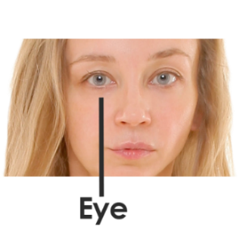 | Eyes |  | Answer | Your notes...
 | Have you had your eyes tested? |  | Yes/No | What date was your eye test:
 | Do you have any eyesight problems or wear glasses? |  | Yes/No
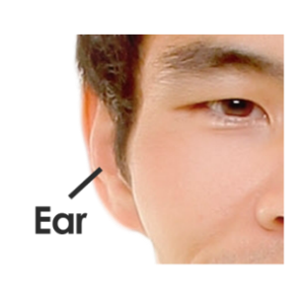 | Ears |  | Answer | Your notes...
 | Have you noticed any problems or changes to your hearing? |  | Yes/No
 | Have you had an ear test? |  | Yes/No | Date:
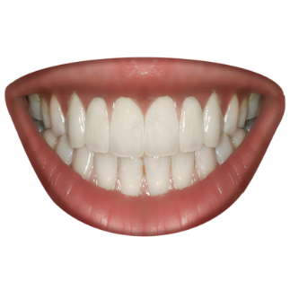  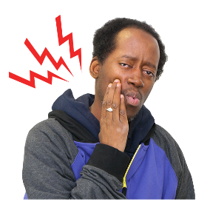 | Teeth |  | Answer | Your notes...
 | Do you have a dentist? |  | Yes/No
 | When was your last visit? |  |  | Date:
 | Do your teeth hurt? |  | Yes/No
 | Do your gums bleed? |  | Yes/No
 | Do you have a swelling or a lump? |  | Yes/No
 | Do you have difficulty eating? |  | Yes/No
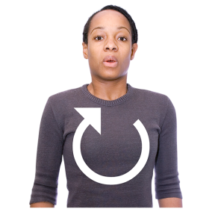  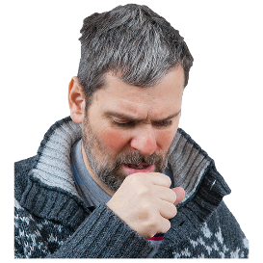 | Respiratory  Chest & Breathing |  | Answer | Your notes...
 | Is it hard to breathe? |  | Yes/No
 | Coughing that won’t go away |  | Yes/No
 | Chest infections |  | Yes/No
 | Coughing up blood |  | Yes/No
 | Unusual coloured spit |  | Yes/No
 | Wheezing |  | Yes/No
 | Hay fever, allergies, asthma? |  | Yes/No
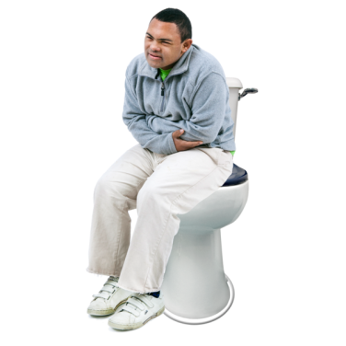 | Bowels and Poo |  | Answer | Your notes...
 | Constipation - hard poo or can’t poo |  | Yes/No
 | Watery poo and going too much |  | Yes/No
 | Bleeding from your bottom |  | Yes/No
 | Difficulty getting to the toilet on time |  | Yes/No
 | Changes in having a poo |  | Yes/No
 | Indigestion |  | Yes/No
Information and easy read guides about constipation
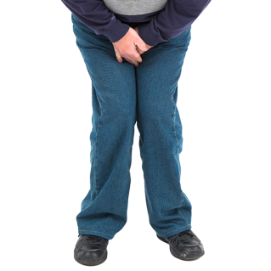 | Urine / wee |  | Answer | Your notes...
 | Does it hurt when you wee? |  | Yes/No
 | Have you had a urine infection? |  | Yes/No
 | Do you wee more often? |  | Yes/No
 | Do you find it difficult to start weeing? |  | Yes/No
 | Do you start and stop when weeing? |  | Yes/No
 | Is there ever blood in your wee? |  | Yes/No
 | Difficulty getting to the toilet on time? |  | Yes/No
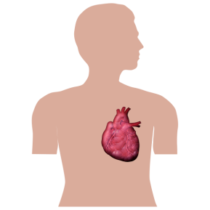 | Heart |  | Answer | Your notes...
 | Is it difficult to breath? |  | Yes/No
 | Do you have chest pain when exercising? |  | Yes/No
 | Any swelling to the ankles, hands or body? |  | Yes/No
 | Epilepsy  Brain |  | Answer | Your notes...
If you have epilepsy please answer these questions.

Please bring your seizure chart with you, if you have one.
 | How many seizures per month?
 | Any changes to seizures? |  | Yes/No
 | Are you under the care of a specialist (neurologist)? |  | Yes/No | When did you last see them?
 | Do you take your epilepsy medication when you should? |  | Yes/No
 | Do you have any side effects i.e. feeling dizzy, sick, irritable or have blurred version? |  | Yes/No
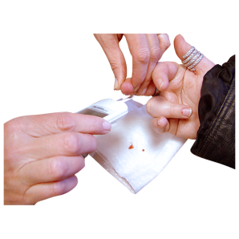 | Diabetes |  | Answer | Your notes...
If you have diabetes please answer these questions

Please bring your blood sugar charts if you have them
 | Do you test your blood sugar regularly? |  | Yes/No
 | Do you have any problems with your eye sight? |  | Yes/No
 | Have you been for your diabetic eye test? |  | Yes/No
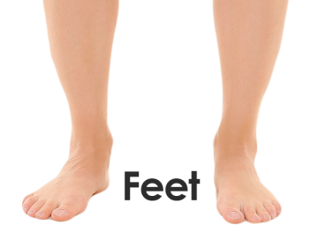 | Feet |  | Answer | Your notes...
 | Have you been to a  podiatrist or foot specialist? |  | Yes/No | If yes when did you go?
 | If no, who cuts your nails? |  | Yes/No
 | Do you have any pain in your feet? |  | Yes/No
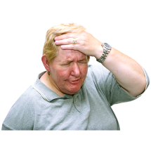 | Pain |  | Answer | Your notes...
 | Do you have any pain? |  | Yes/No
 | Does your pain medicine help? |  | Yes/No
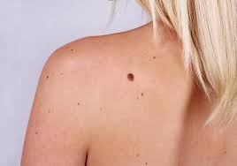 | Skin |  | Answer | Your notes...
 | Do you have Dry or Itchy Skin? |  | Yes/No
 | Changes to moles? |  | Yes/No
 | Cold Sores? |  | Yes/No
 | Sores or open wounds? |  | Yes/No
 | Changes to the colour of your skin? |  | Yes/No
 | Mental Health |  | Answer | Your notes...
 | Feeling low, sad or unhappy? |  | Yes/No
 | Feeling worried, frightened or anxious? |  | Yes/No
 | Do you feel like crying? |  | Yes/No
 | Do you feel like you can’t cope? |  | Yes/No
 | Do you feel irritable, aggressive or violent? |  | Yes/No
 | Think about hurting yourself or actually hurt yourself? |  | Yes/No
 | Sleeping too much or not sleeping? |  | Yes/No
 | Do you hear voices or see things? |  | Yes/No
 | Worries about your memory or confusion? |  | Yes/No
 | Have you spoken to someone about  how you feel? |  | Yes/No
Mental Health and Learning Disabilities information

Easy Read leaflets and guides

 | Medication Review  Your Doctor will talk to you about your medicines to make sure your medicines are right for you.
Do you have any concerns or questions about your medication? |  |  | Yes/No
Guide for supporting a person to a GP appointment to talk about psychotropic medication
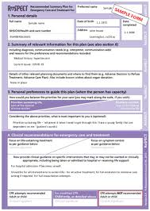 | End of Life Care
Do you have a ‘DNAR’ (Do Not Attempt  Resuscitation) or ‘ReSPECT’ (Recommended Summary Plan for Emergency Care and Treatment) Form? |  | Yes/No
Do you have any concerns or questions about these documents? |  | Yes/No
RESPECT information for patients and carers
My Care Passport

Help hospital staff understand how to help you. Click here for your My Care Passport.
Do you have a My Care Passport? |  | Yes/No
 | Do you have any Questions?  Is there anything you want the Doctor or Nurse to know?
 | Health Action Plan  At the end of your Annual Health Check you should get a copy of your Health Action Plan.
 | Thank you for filling out this form  Please email it back to your GP surgery or bring it to the Annual Health Check Meeting.

My Health Action Plan

Notes

 | What I will do?   | When I will do it   |  | Who will help me?  
  I have done it!
 | 


